EU Exporters' Stories
Pacific Bio Lubricants Ltd
- green tech for smooth running machinery
__________________________________________________________________________________________

Pacific Bio Lubricants Ltd is an Auckland-based subsidiary of the Czech company BIONA. They develop, manufacture and offer a range of environmentally friendly oils and lubricants under the LUBECO brand.

Key info
Founded: 1994
Employees: 40
Headquarters: Jersin, Czech Republic
Annual turnover: €10 M

LUBECO are biodegradable oils and lubricants used in different industrial and domestic applications. New Zealand has one of the highest per capita ownership of chainsaws in the world, which is why LUBECO’s biodegradable chainsaw oil is one of Pacific Bio Lubricants’ best-sellers on the New Zealand market.

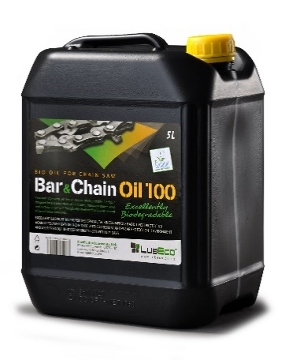

It all started when Chairman Mr Ladislav Zelenka of the BIONA Group visited New Zealand and was amazed with its beautiful nature and sound economy. But he was puzzled that there were no requirements for use of bio-based lubricants, even in high risk areas such as forestry, fishing, agriculture, etc.

After his holiday the planning to expand BIONA’s EU Ecolabel-products to New Zealand began and since 2014 Pacific Bio Lubricants Ltd has become a leading supplier to the market.

How an EU-New Zealand Trade Agreement could help:
Standards | The negotiations for a trade agreement between EU and New Zealand aim to recognize each other’s standards. That means that the EU Ecolabel that Pacific Bio Lubricants use could be recognized in New Zealand.
Environmentally friendly technology | The world will benefit from increased trade in products that are green, sustainable and more environmentally friendly such as the LUBECO bio-lubricants. Mutually recognized green standards would make it easier for environmentally responsible companies to compete on the respected markets.

"We proudly carry the EU Ecolabel certification as a global benchmark for our products decreasing environmental impact. A free trade agreement that align the partners standards, such as the EU Ecolabel would benefit hugely to our green products in New Zealand market.”

Michal Kadlec
Director
Pacific Bio Lubricants Ltd

